How to get to the hostel
Adress: Hostel Císařka, Podbělohorská 97, Praha

Costs: one ticket (adult) costs 26,- CZK. Tickets can be purchased at the ticket machine if you have coins, in the newspaper shop, or alternatively by the bus-driver (30,- CZK).

You can also buy a SMS ticket (only when you have a Czech mobile sim-card!):
- On your mobile communications device, write the text: DPT
- Send it to the phone number 902 06 26.

Within approximately two minutes, an SMS ticket will arrive. This time is only an estimate. A SMS ticket will appear on the display of the mobile communications device.

From the Prague Main Railway Station (Praha, Hlavní nádraží, about 30 minutes)
Take underground (metro) red line C from the railway station (towards Ládví) to Florenc (1st stop) and change to the yellow line B (towards Zličín) to Anděl (5th stop).

From Anděl take bus no. 191 (towards Petřiny) to bus stop Spiritka (5th stop, about 10 minutes). The hostel is just next to the bus stop.

From the Railway Station Praha Holešovice
Take underground (metro) red line C (towards Háje) to Florenc (2nd stop) change for the yellow line B (towards Zličín) to the station Anděl (5th stop).

From Anděl station take bus no. 191 (towards Petřiny) to Spiritka (5th stop, about 10 minutes). The hostel is just next to the bus stop.

From the airport (about 45 minutes)
Take bus no. 179 to Větrník (15th stop, 25 minutes) and there change to the bus no. 191 (towards Na knížecí) to Spiritka (7th stop, 10 minutes). The hostel is just next to the bus stop

From the Florenc bus station (about 25 minutes)
Take underground (metro) yellow line B (towards Zličín) to the station Anděl (5th stop).

From Anděl station take bus no. 191 (towards Petřiny) to the bus stop Spiritka (5th stop, about 10 minutes). The hostel is just next to the bus stop.

All maps below are taken from the website: www.mapy.cz

Exactly from URL: http://www.mapy.cz/#x=132949555@y=135914545@z=16@mm=ZP@sa=s@st=s@ssq=podb%C4%9Blohorsk%C3%A1%2097,%20praha@sss=1@ssp=132935296_135853312_133051008_135956352

Location of the hostel in the Prague center:
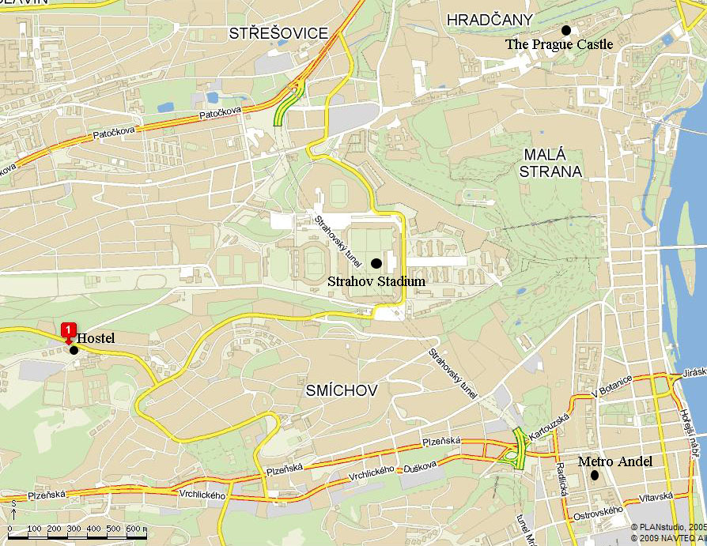

The neighbourhood of the hostel:
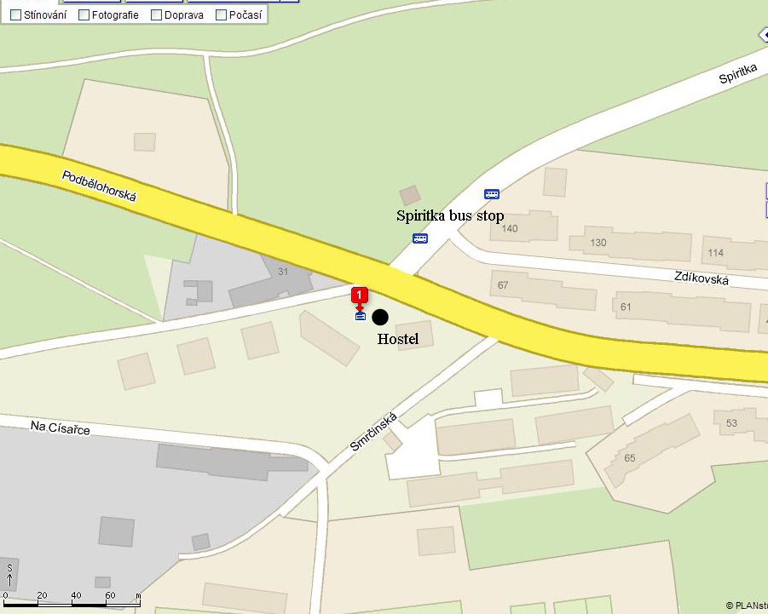

The way from the airport by the bus lines 179 and 191:
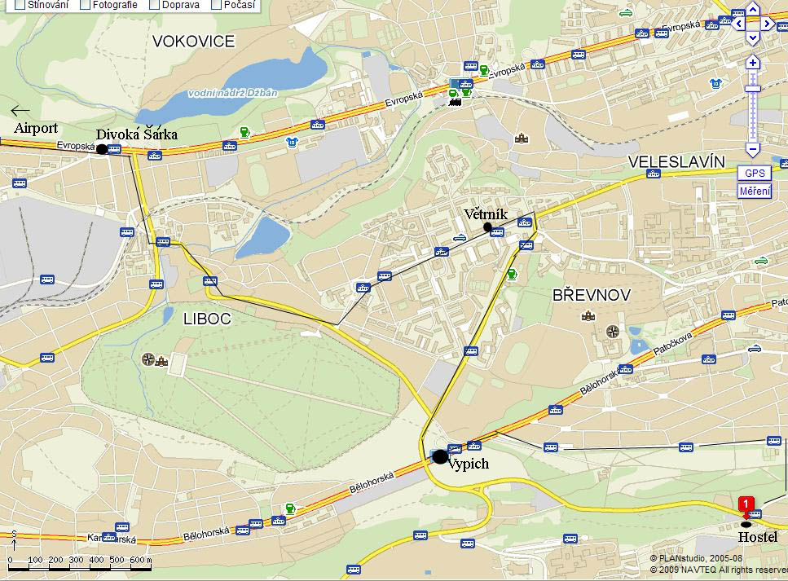

Change in the Anděl (from metro station Anděl to bus no. 191):
